TC-CMS-016
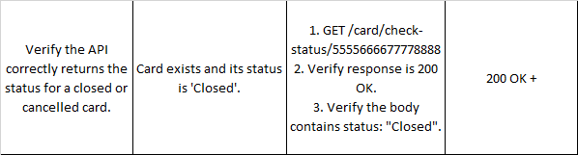
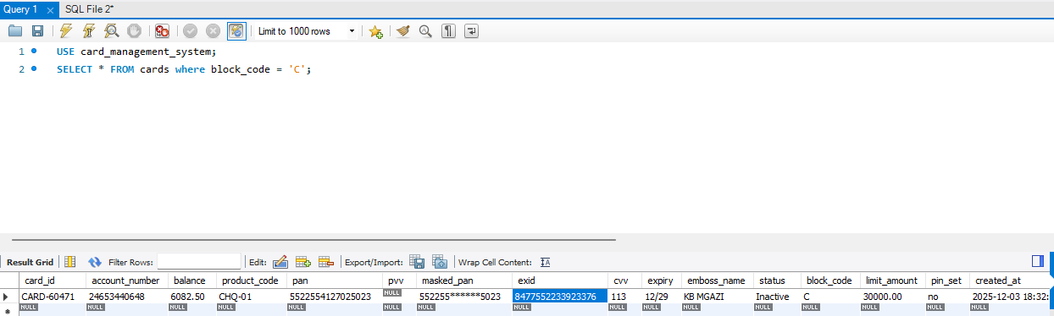
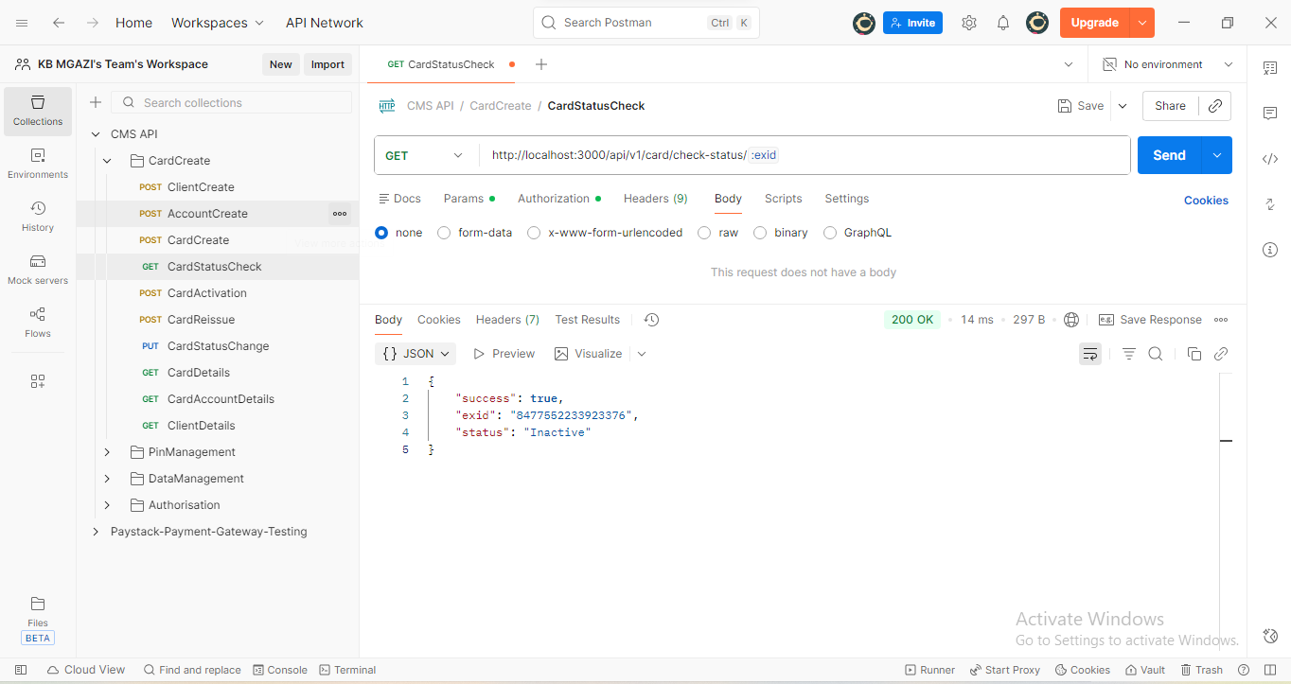
Response:
{
"success": true,
"exid": "8477552233923376",
"status": "Inactive"
}

